**Lab 0 - Introduction to Microcontrollers and Lab Tools**

The objective of this lab is to get a hands-on experience with microcontroller devices, understand the basics of IO, the operations involved to design and configure a simple of complicated project, and development of such systems.

This lab consists of three parts. In part one, we are going to program the microcontroller board to make a program that turn on 3 LED lights in unique pattern when a button is pressed. For part two, we are going to modify the FSM given in the “ Lab 0 - Introduction to Microcontrollers and Lab Tools” pdf, to make e North-South road traffic light green only when a switch is pressed. Lastly, part three will be introduction to Analog Discovery WaveForms application.   
  
The software used in this lab are STM32CubeMx, Atollic TrueStudio, and WaveForms. And, some of the hardware used are STM32 Nucleo F303K8, USb Micro, Breadboard 830 point, 330 ohm resistor, LED, push button, 1K ohm resistor, 20K ohm potentiometer, XK ohm, and Assorted Male to Male jumper wires.

**Part 0: Installing the Software & Part 1: General Purpose Input / Output**

In these two parts we are going to install and set up STM32CubeMx and Atollic TrueStudio. The goal of this part is to gain enough knowledge to make simple programs using STM32CubeMx andAtollic TrueStudio. By the end of this part, we are going to work on make a program to control 3 LEDs that turn on and off in unique pattern by a single button.

* Install STM32CUBEMX  
   
* Install Atollic True Studio

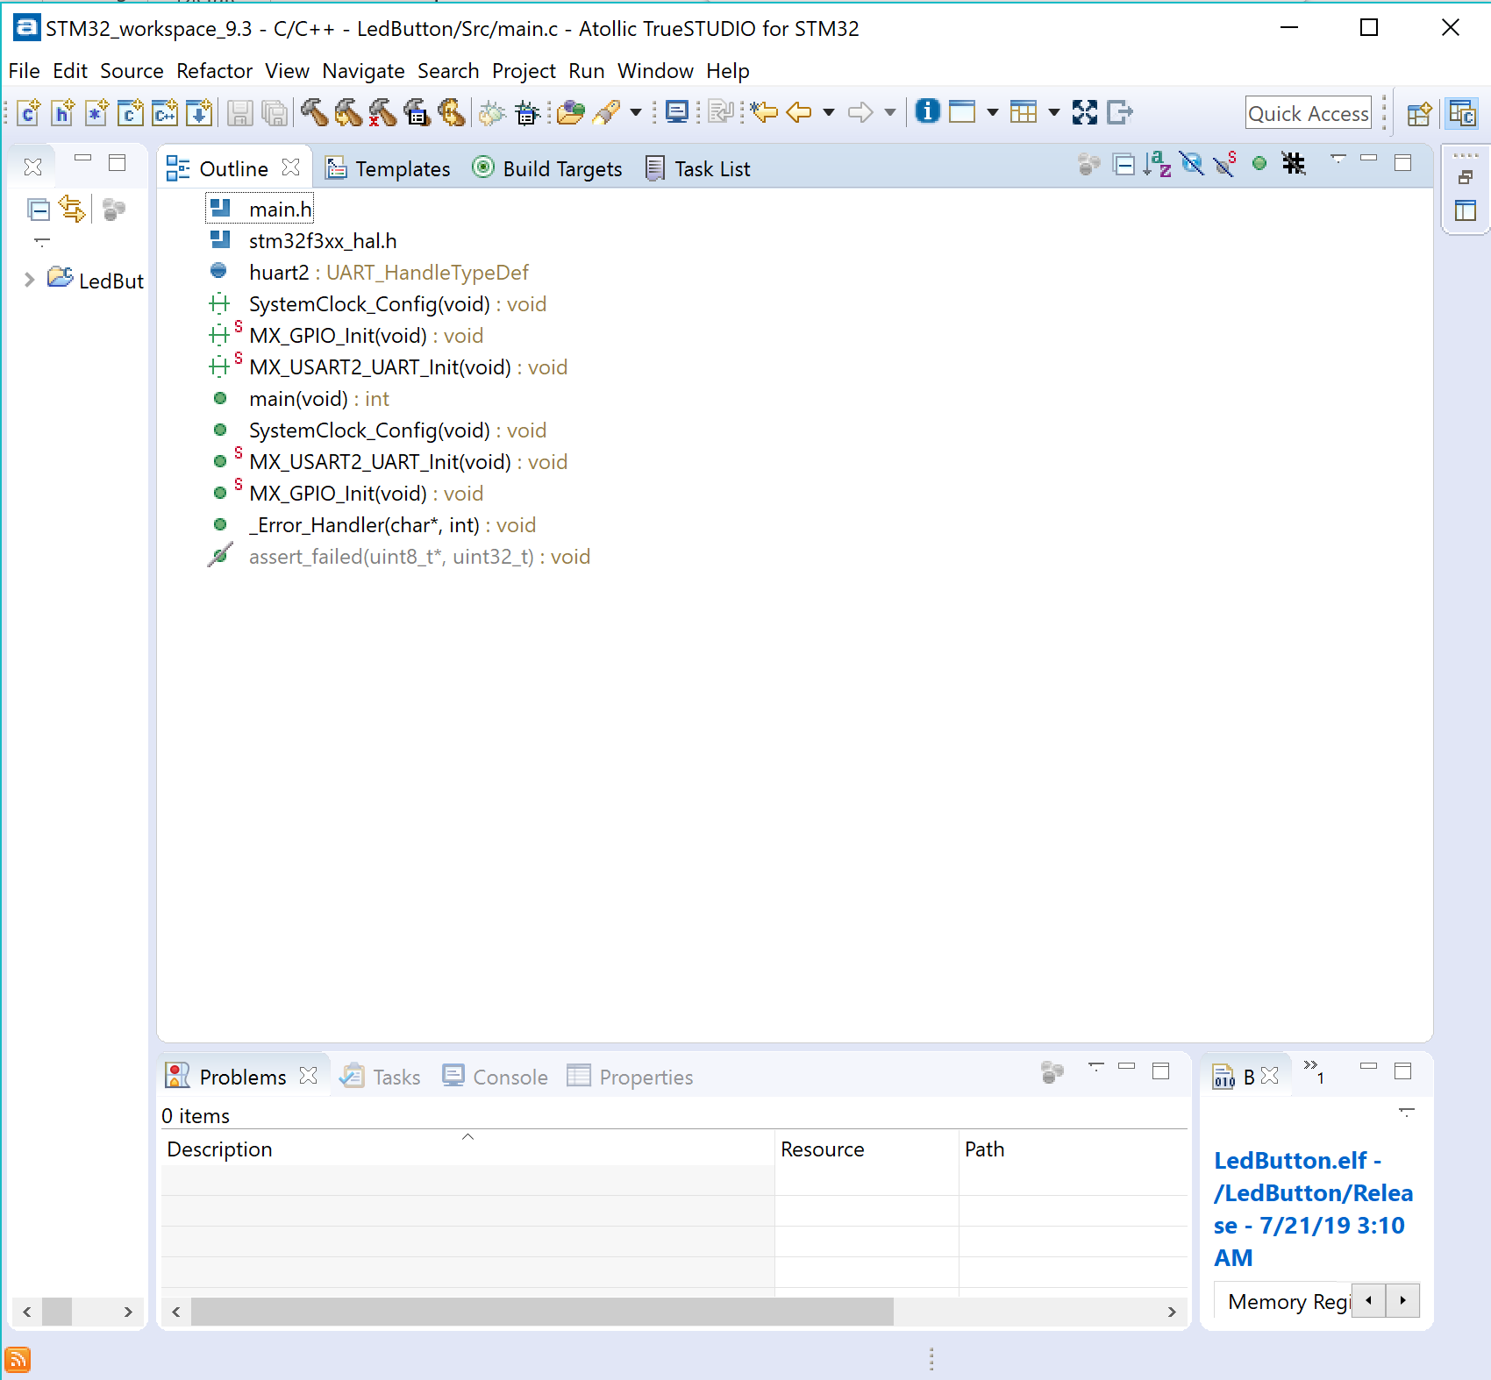

**General Purpose Input / Output**

1. **Introduction :** The introduction section explains what is the GPIO process, GPIO is a uncommitted pin on a chip that can be configured into a digital input or output. GPIO STM 32 structure is basically a pull up and done resistors, Schmitt trigger, and n-mos and p-mos. Each of these build in hardware have a important task. For instant, Schmitt trigger to help avoid input signal and contact bounce, and n-mos and p-mos help manage the pin states in push-pull mode and in open-drain mode.
2. **Polling Based :** In this section we are going to build and configure the breadboard.  
     
   - Hardware configuration: We connected the push button and the led circuit to the breadboard as follow.  
     
   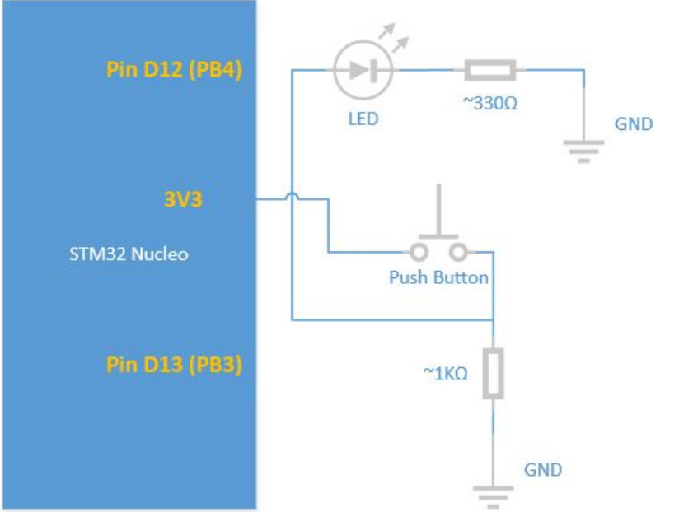  
     
   --- another live pic ----  
     
     
     
     
     
     
     
     
     
     
     
     
     
     
     
   - Software Configuration:   
     
   1. The first step is to select board in STM32CubeMX, as follow:  
     
   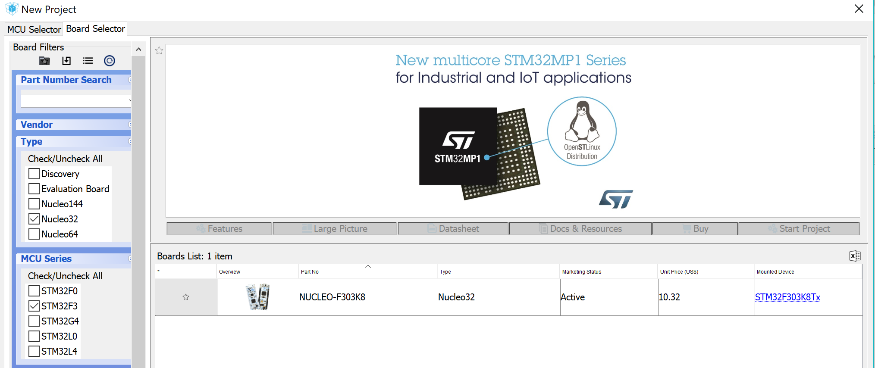  
   2. The second step is to configure the pins and some of settings on the device so it can connect correctly to the computer, as follow:   
     
   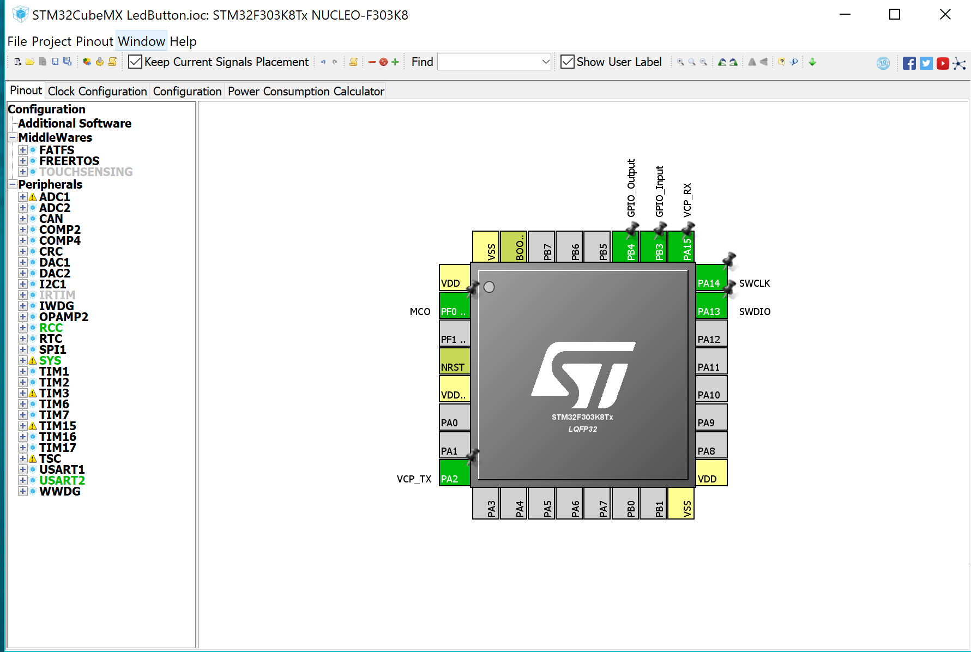  
     
   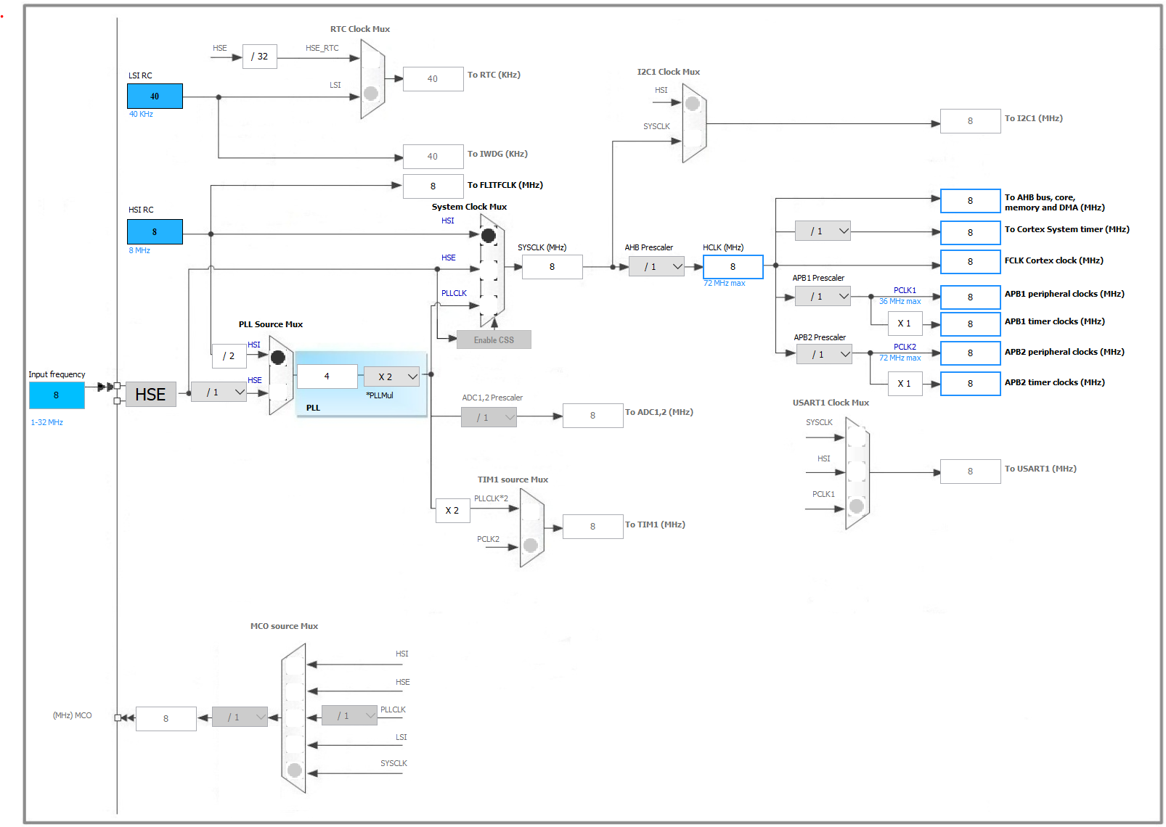  
     
   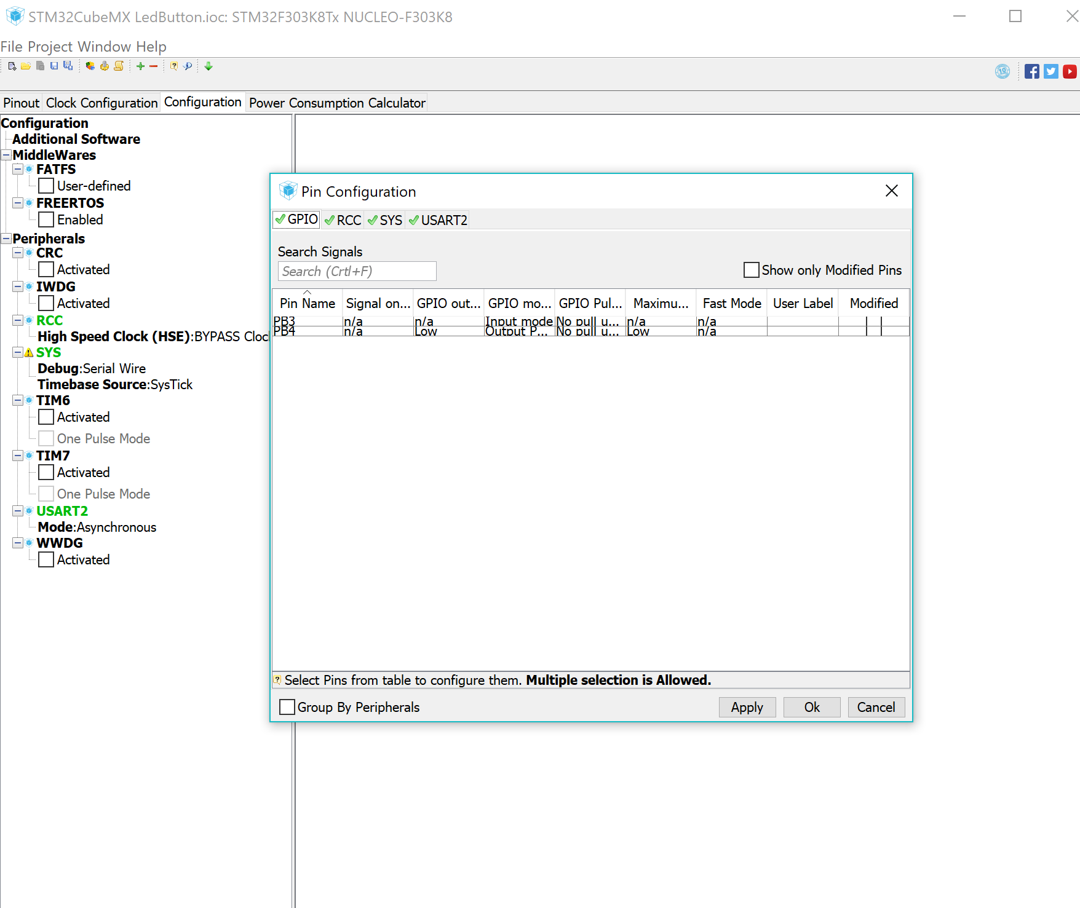  
     
   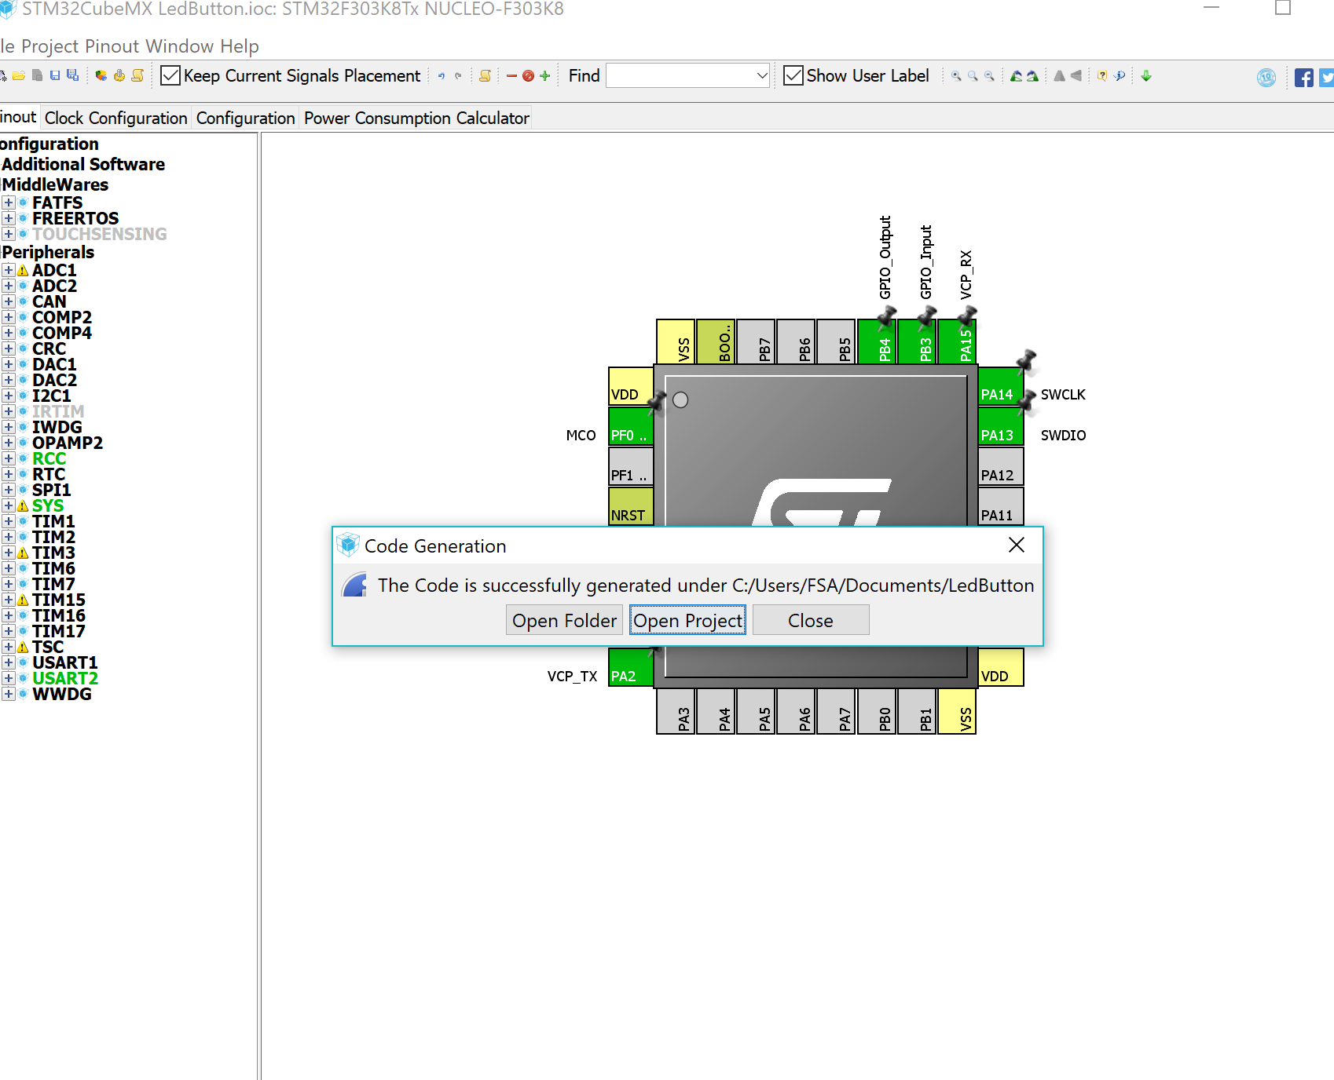  
     
     
   **AFTER WE GENERATED THE CODE IN STM32CubeMX WE WILL RUN IT USING** **Atollic TrueStudio.**3. Now we can start to write the code in Atollic TrueStudio. We will add the following code into infinite while loop.  
     
     
     
     
     
     
     
     
     
     
     
     
   And we are going to use the Build Project option to build it.  
     
   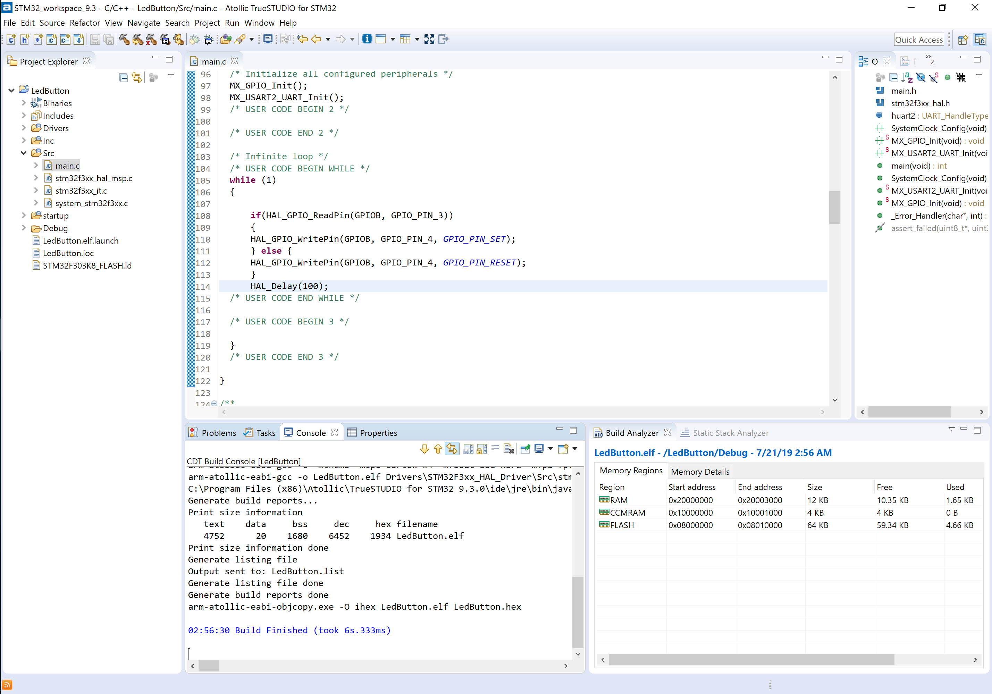  
     
     
   4. After successfully completing the building process we are going to use the Debug functionality to make sure it is error-free.  
     
   RUN > Debug Configuration.  
     
   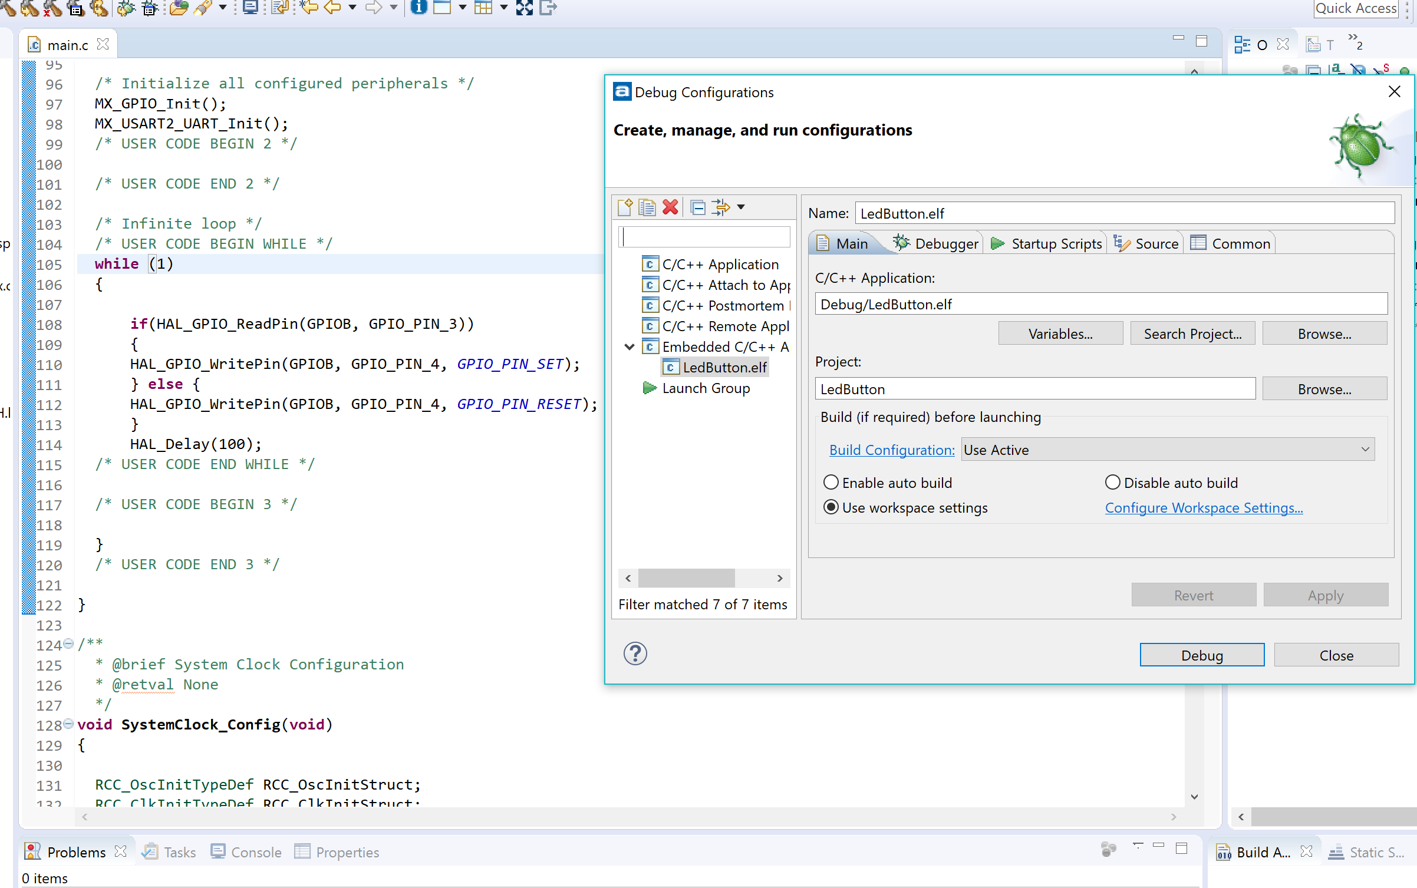   
   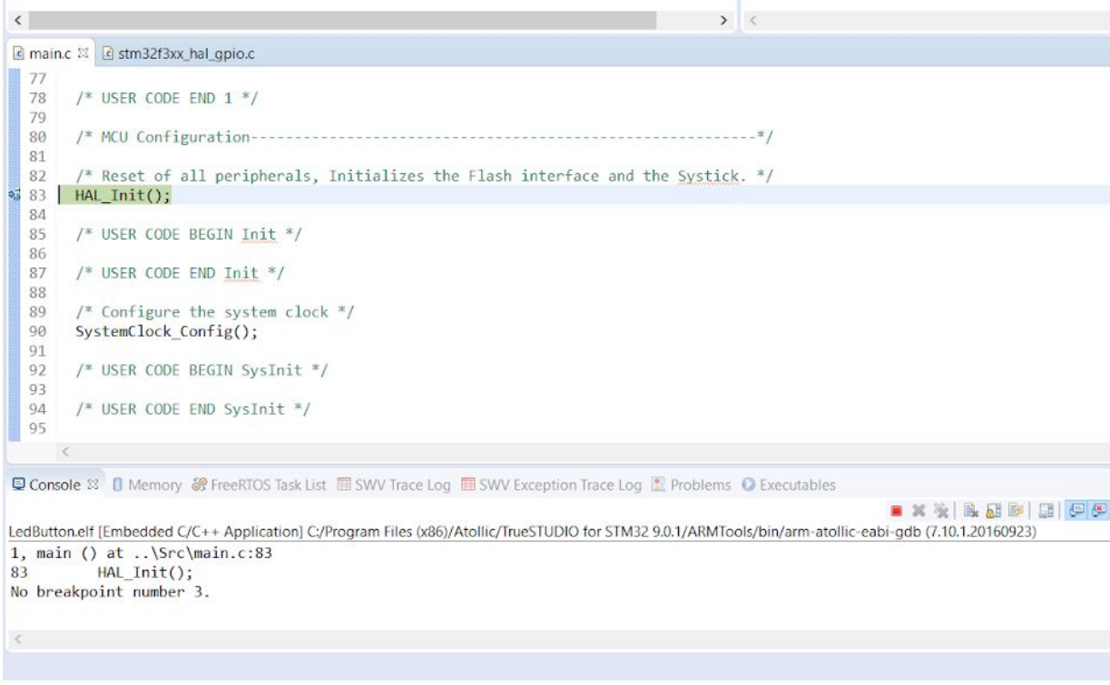

**if(HAL_GPIO_ReadPin(GPIOB, GPIO_PIN_3))**

**{**

**HAL_GPIO_WritePin(GPIOB, GPIO_PIN_4, GPIO_PIN_SET);**

**} else {**

**HAL_GPIO_WritePin(GPIOB, GPIO_PIN_4, GPIO_PIN_RESET);**

**}**

**HAL_Delay(100)**

1. **Interrupt Based :** In this section we are going to examine how we can configure the GPIO pins to have an external interrupt on the input pin.

We need to build the breadboard. We are going to build it just like we did previously.   
  
- Hardware configuration: We connected the push button and the led circuit to the breadboard as follow.  
  


- Software Configuration:  
  
  
1. The first step is to select board in STM32CubeMX, as follow:  
  
  
2. The second step is to configure the pins and some of settings on the device so it can connect correctly to the computer, as follow:   
  
 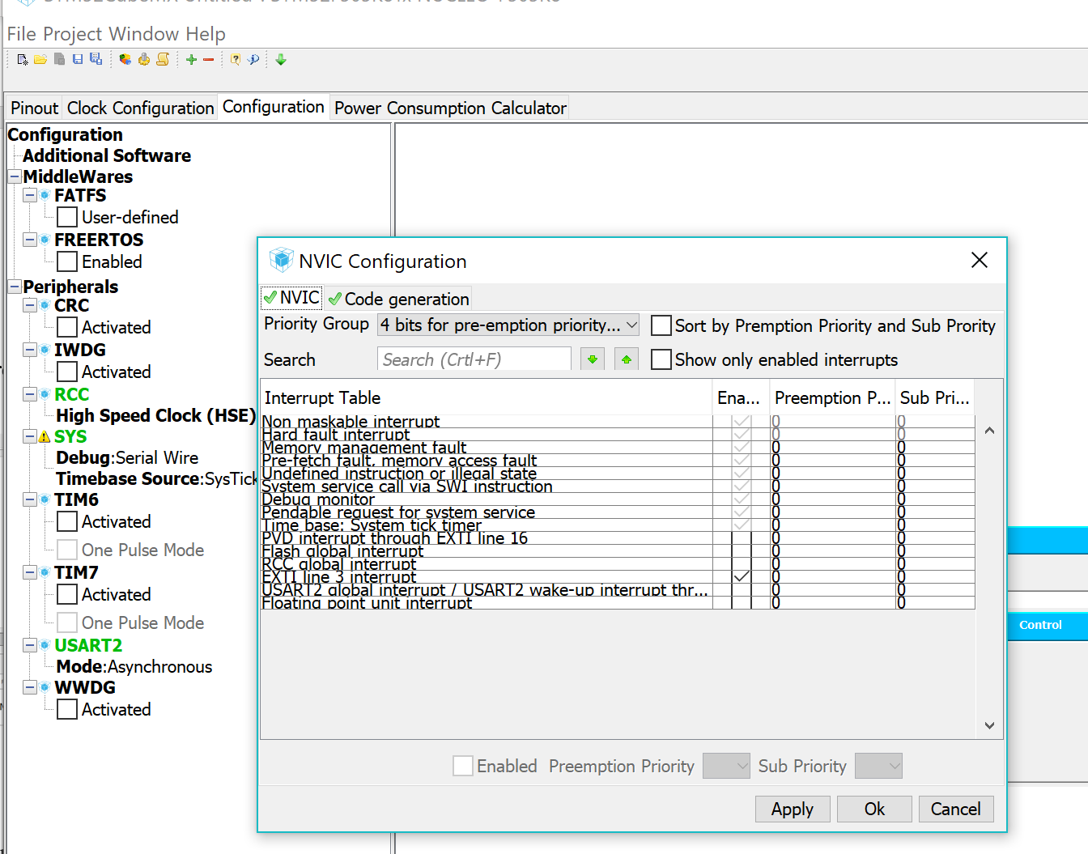  
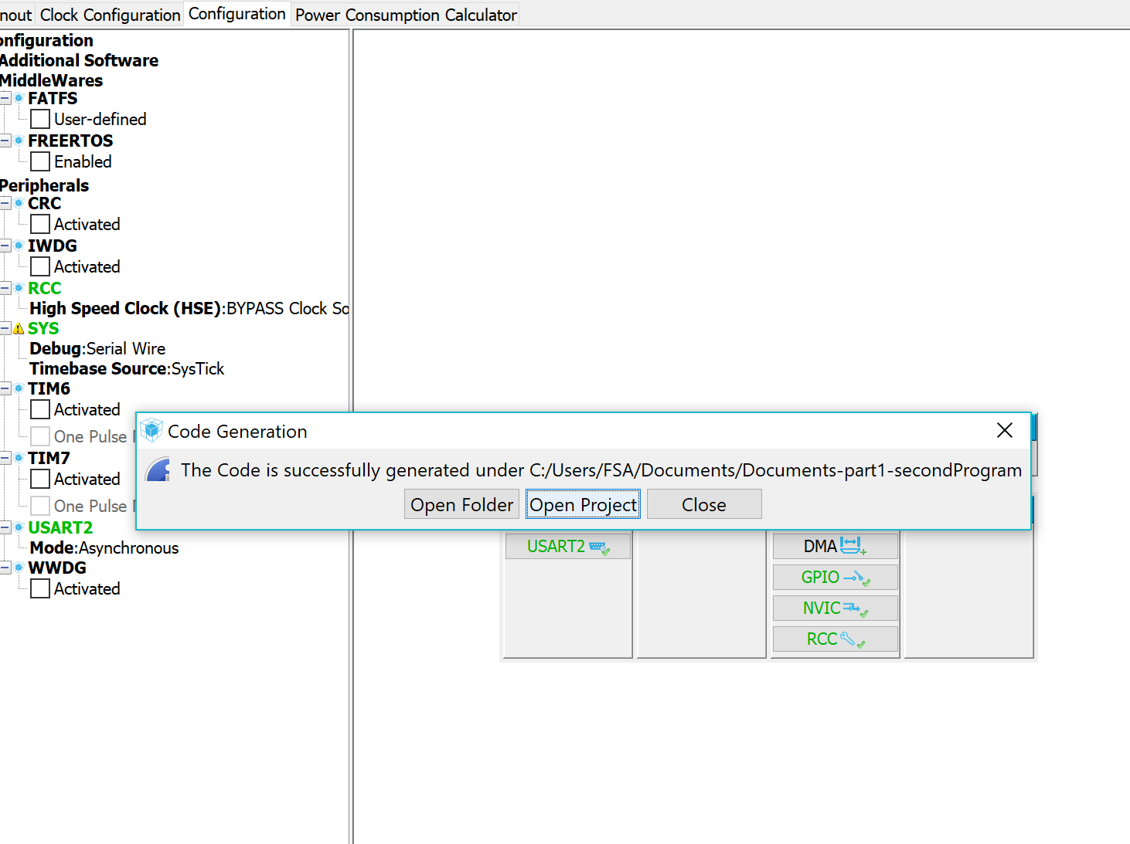

**AFTER WE GENERATED THE CODE IN STM32CubeMX WE WILL RUN IT USING Atollic TrueStudio.**

3. Now we can start to write the code in Atollic TrueStudio. We will add the following code into infinite while loop.

**/* USER CODE BEGIN EXTI3_IRQn 0 */**

**HAL_GPIO_TogglePin(GPIOB, GPIO_PIN_4); //Toggle the state of pin PC9**

**/* USER CODE END EXTI3_IRQn 0 */**

**HAL_GPIO_EXTI_IRQHandler(GPIO_PIN_3);**

**/* USER CODE BEGIN EXTI3_IRQn 1 */**

**/* USER CODE END EXTI3_IRQn 1 */**

**Code 2. HAL Li**

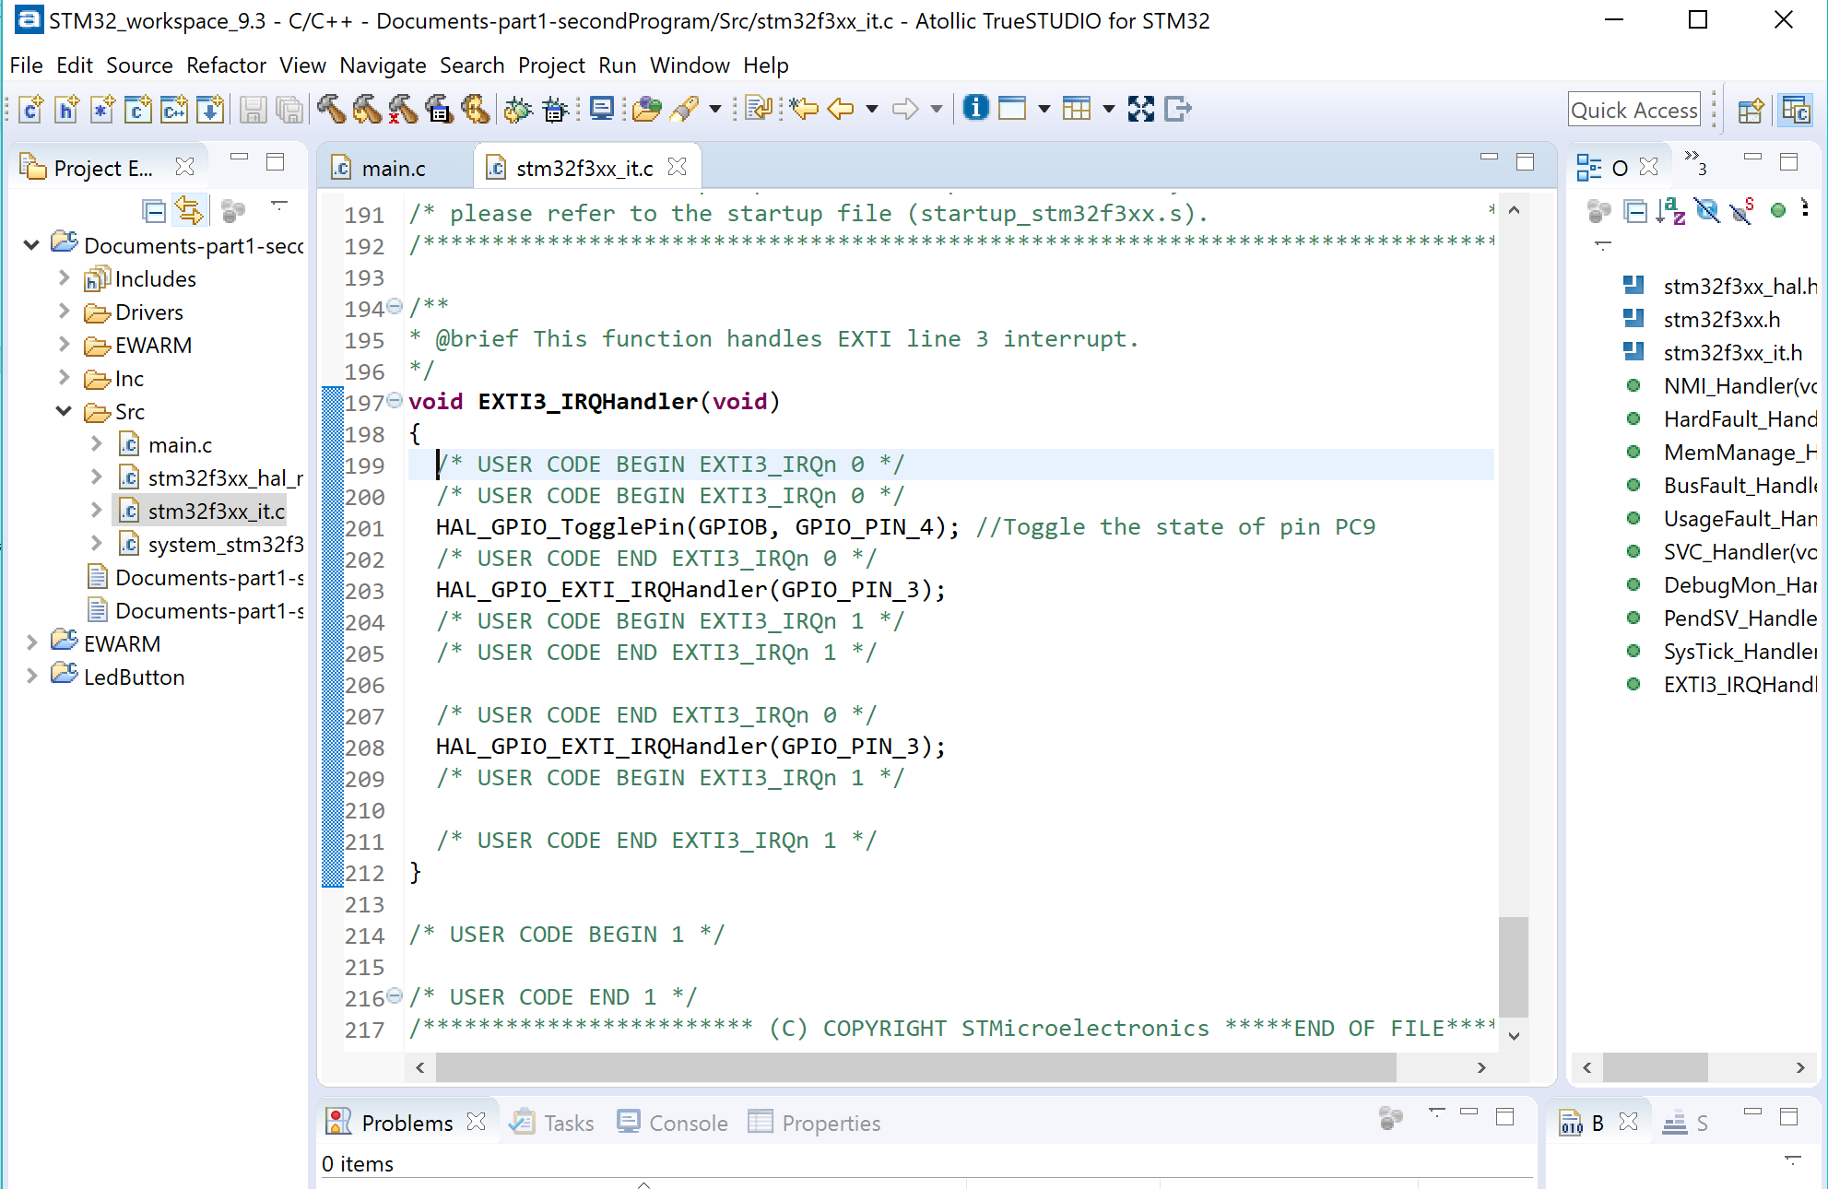

4. And we are going to use the Build Project option to build it.  
  
We run into few problems trying to build it. One of them is missing function with in main import line. With some debugging we were able to locate the issue, there was a file which is not in the same directory. So we had to look for file and move it to the same directory.  
  
Finally..We got it.

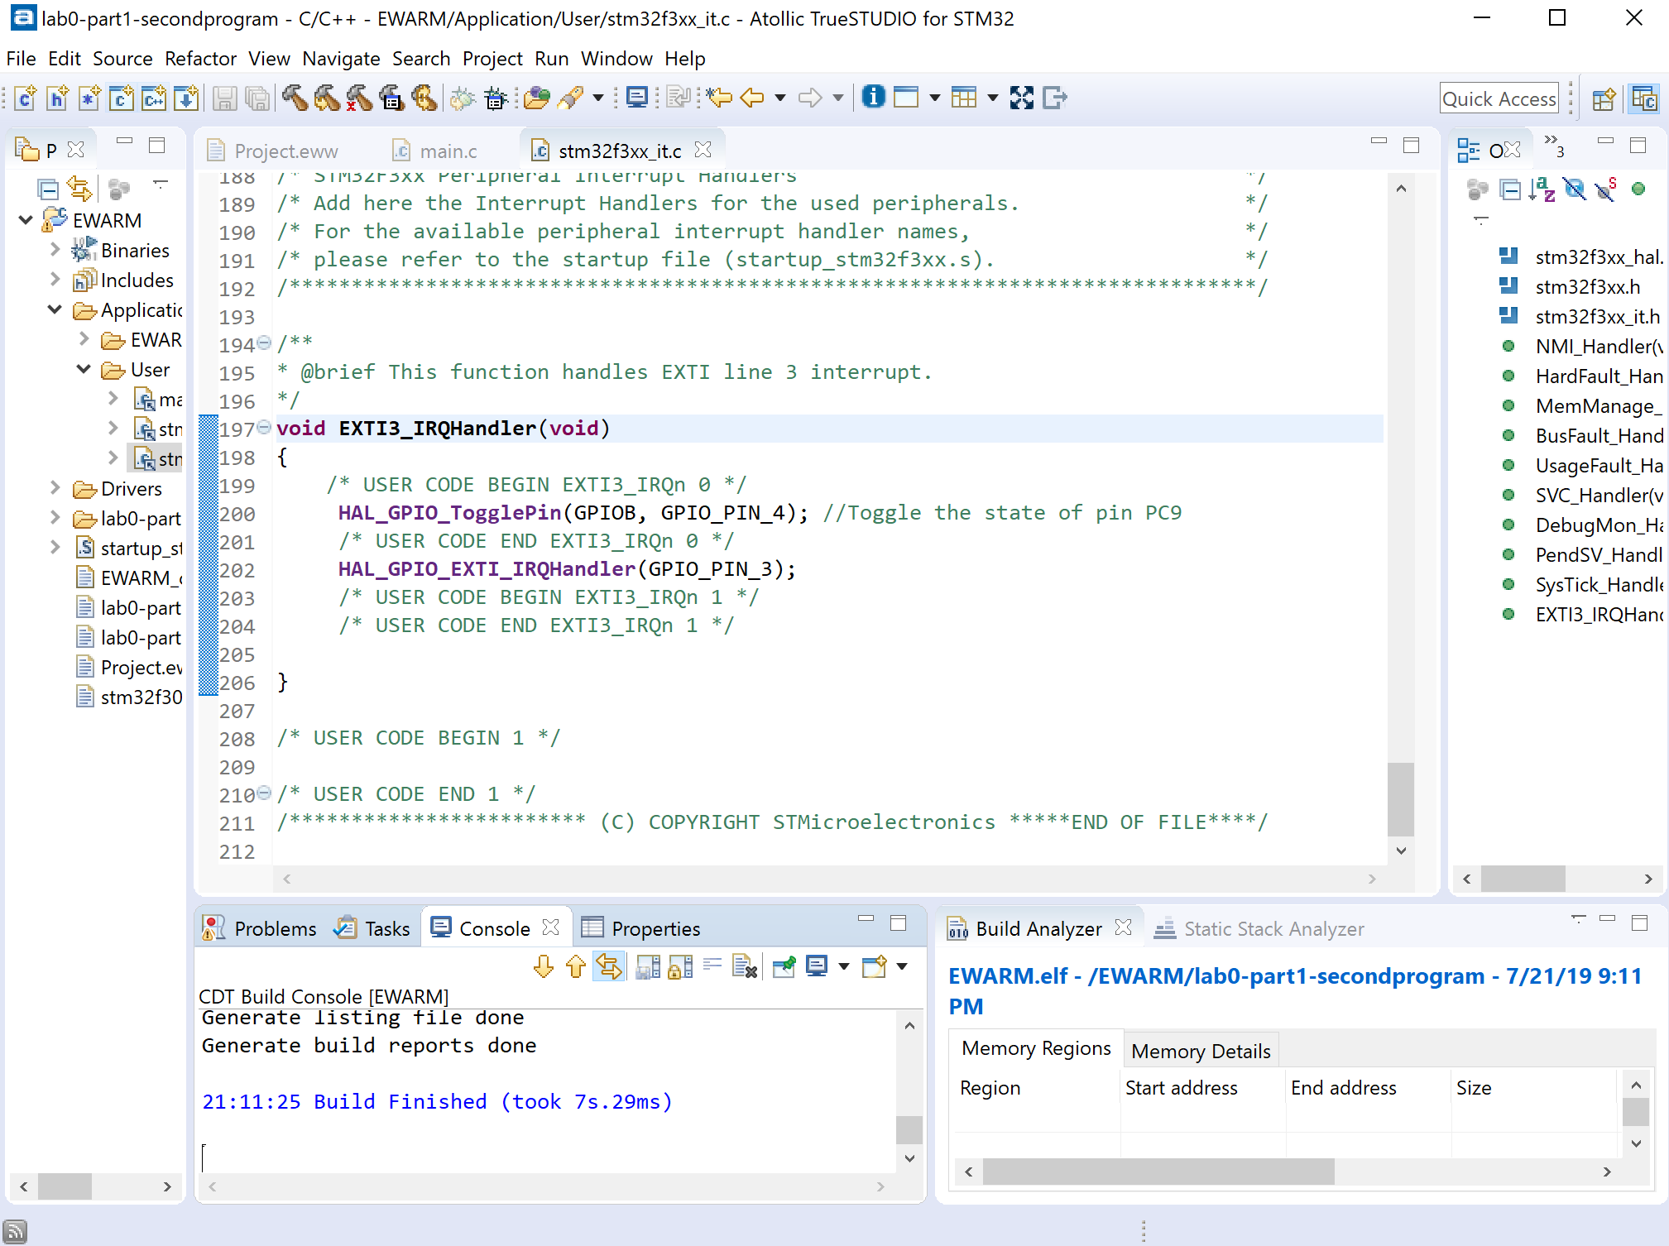

1. **Practical Exercise :**   
     
   To demo this section, we had to add two more LEDs to be able get three lights blinking in unique pattern.

The actual circuit is similar to what we had earlier with adding two lights same way with two more resisters.   
  
**The code is:**  
  
  
  
  
  
  
  
  
  
  
  
  
The STM32 Configuration:  
  
**PB3:** is the button pin which is input **PB4:** light 1 **PB5:** light 2 **PB6:** light 3  
  
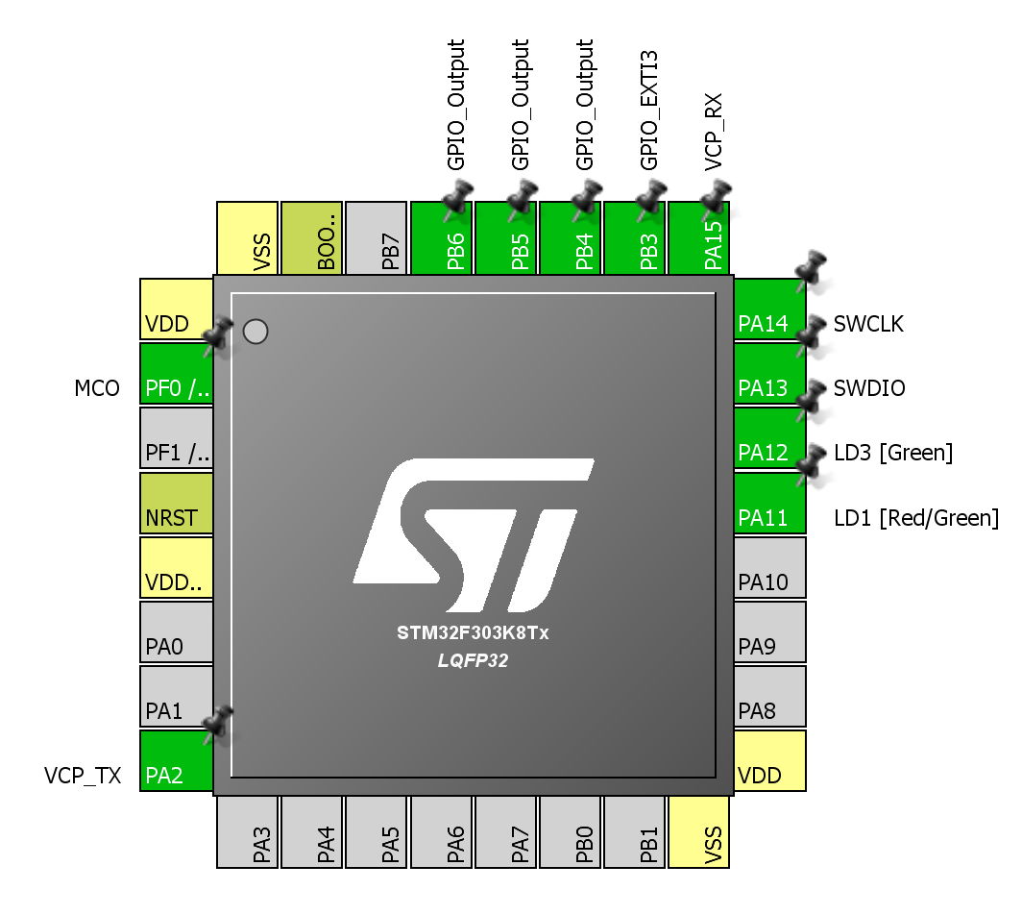

  if(HAL_GPIO_ReadPin(GPIOB,GPIO_PIN_3)){  
 HAL_GPIO_WritePin(GPIOB, GPIO_PIN_4, GPIO_PIN_SET);  
 HAL_GPIO_WritePin(GPIOB, GPIO_PIN_6, GPIO_PIN_SET);  
 HAL_GPIO_WritePin(GPIOB, GPIO_PIN_5, GPIO_PIN_SET);  
 HAL_Delay(500);  
 HAL_GPIO_WritePin(GPIOB, GPIO_PIN_5, GPIO_PIN_SET);  
 HAL_GPIO_WritePin(GPIOB, GPIO_PIN_4, GPIO_PIN_RESET);  
 HAL_GPIO_WritePin(GPIOB, GPIO_PIN_6, GPIO_PIN_RESET);  
 HAL_Delay(500);  
 HAL_GPIO_WritePin(GPIOB, GPIO_PIN_5, GPIO_PIN_SET);  
 HAL_GPIO_WritePin(GPIOB, GPIO_PIN_6, GPIO_PIN_SET);  
 HAL_GPIO_WritePin(GPIOB, GPIO_PIN_4, GPIO_PIN_SET);  
 HAL_Delay(500);  
 HAL_GPIO_WritePin(GPIOB, GPIO_PIN_6, GPIO_PIN_SET);  
 HAL_GPIO_WritePin(GPIOB, GPIO_PIN_4, GPIO_PIN_SET);  
 HAL_GPIO_WritePin(GPIOB, GPIO_PIN_5, GPIO_PIN_SET);  
  }else{  
 HAL_GPIO_WritePin(GPIOB, GPIO_PIN_4, GPIO_PIN_SET);  
 HAL_GPIO_WritePin(GPIOB, GPIO_PIN_5, GPIO_PIN_SET);  
 HAL_GPIO_WritePin(GPIOB, GPIO_PIN_6, GPIO_PIN_SET);  
  }  
  HAL_Delay(500);

**To set up the software and hardware just like the last part.   
  
  
  
  
  
  
Live picture of the circuit**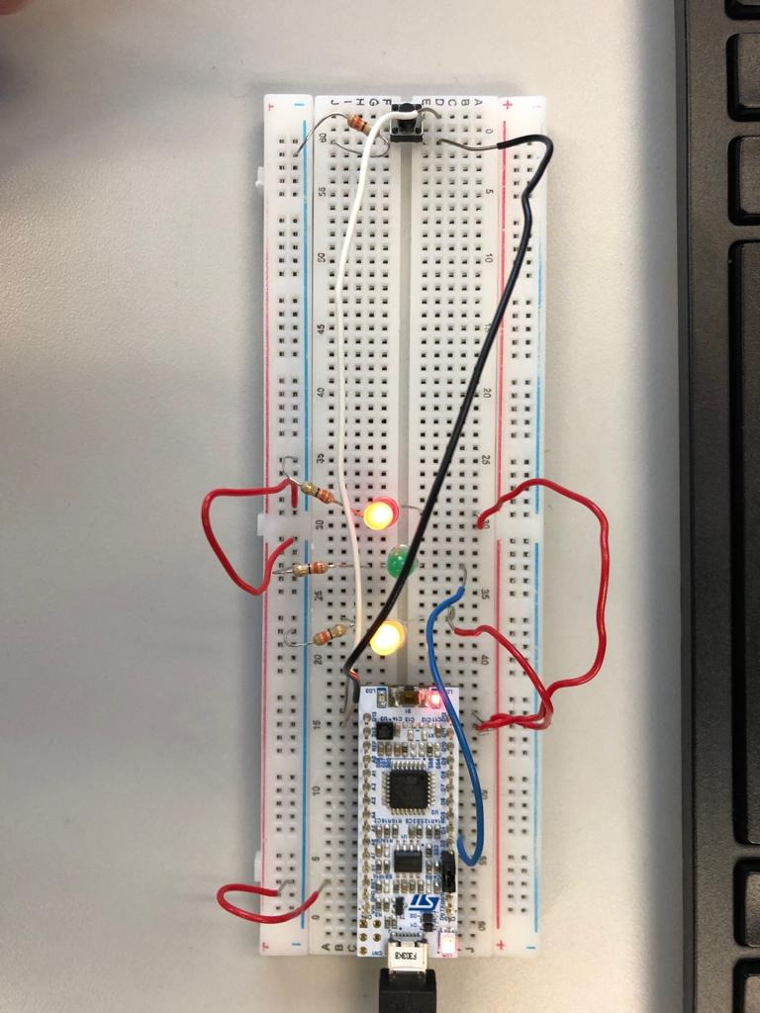

The logic between the first blinking light in section A and the above demo is basically in the logic of the circuit and in the programing itself.

To do the first LED light we need it only to connect the STM32 to the breadboard and using one of the ports in Ds section, voltage source 3.3v, and a resistor that connected to the ground. When the circuit is connected just like I described it above, the LED light turns on.

For the demo, we needed to modify the circuit to make it hold two additional LEDs. And, add a button that controls the lights. As you can see in the STM32 screenshots, four pins were configured PB 3, 4, 5, 6. 3 for input and three are output.   
  
When we push the button, we notice the LED lights turns on and stays on for the setup period in the programming part ( ie see the **code in part D - Practical Exercise** ). The pattern follows the code. Turns on and off and the delay time all based on the code.

**Part 2: Finite State Machines Software Design Pattern**For this part, we are going to build a Finite State Machines (FSM) that represent a traffic light. To do this part we are going to modify the software and hardware in **Section D of Part 1**.  
  
Now that we design of our finite state machine we are going to implement it with our microcontroller and 6 LEDs. For the next part we will need 3 more LEDs combined with **Section D of Par**.Total of 6 LEDs.   
  
  
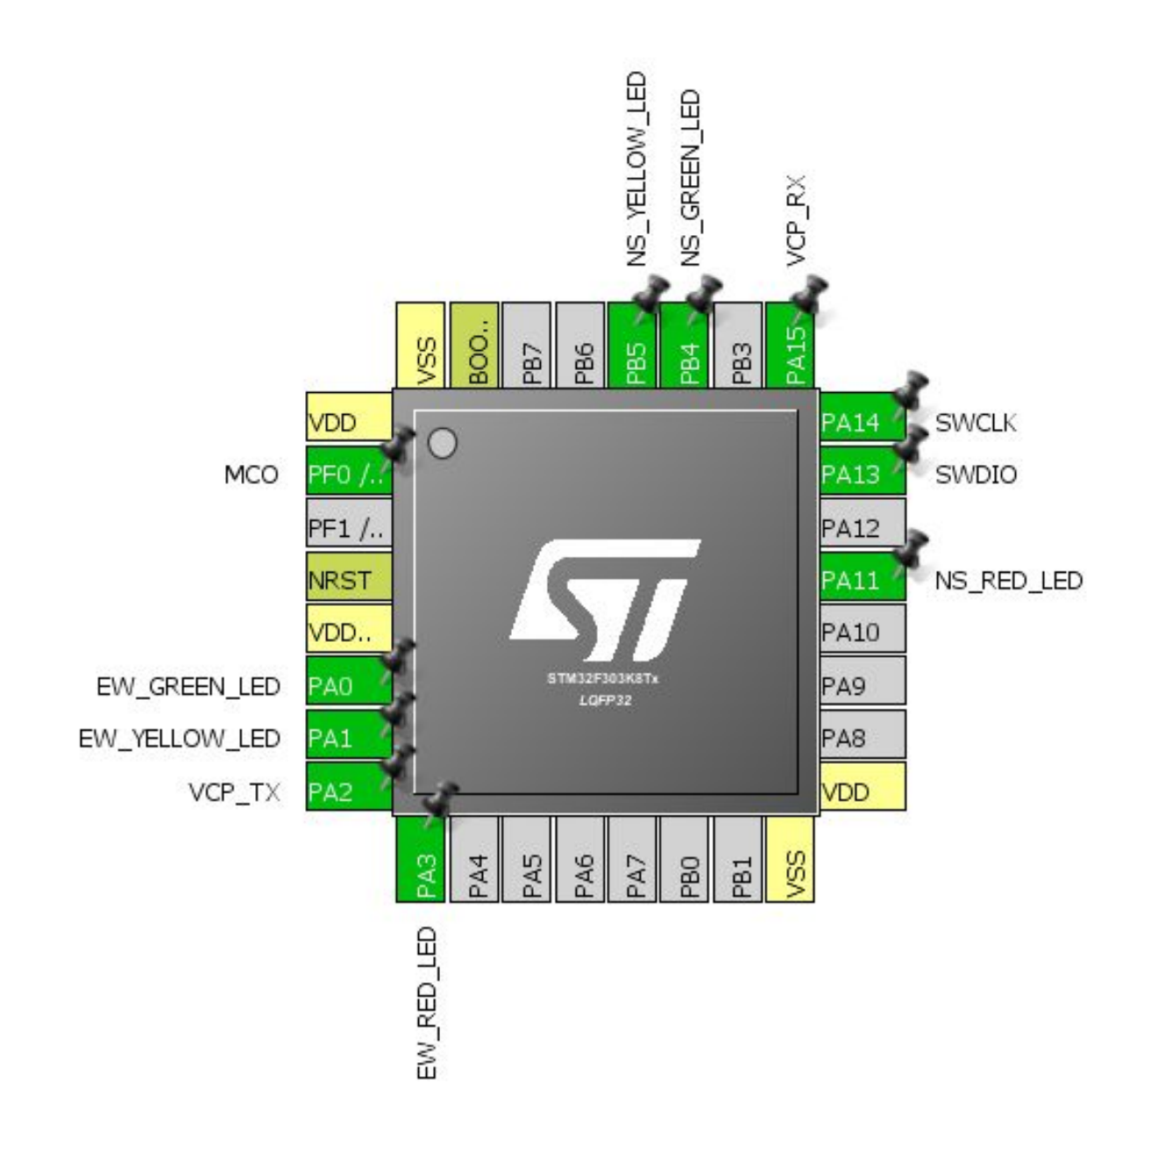  
  
As we can see, there are 6 pins configured.

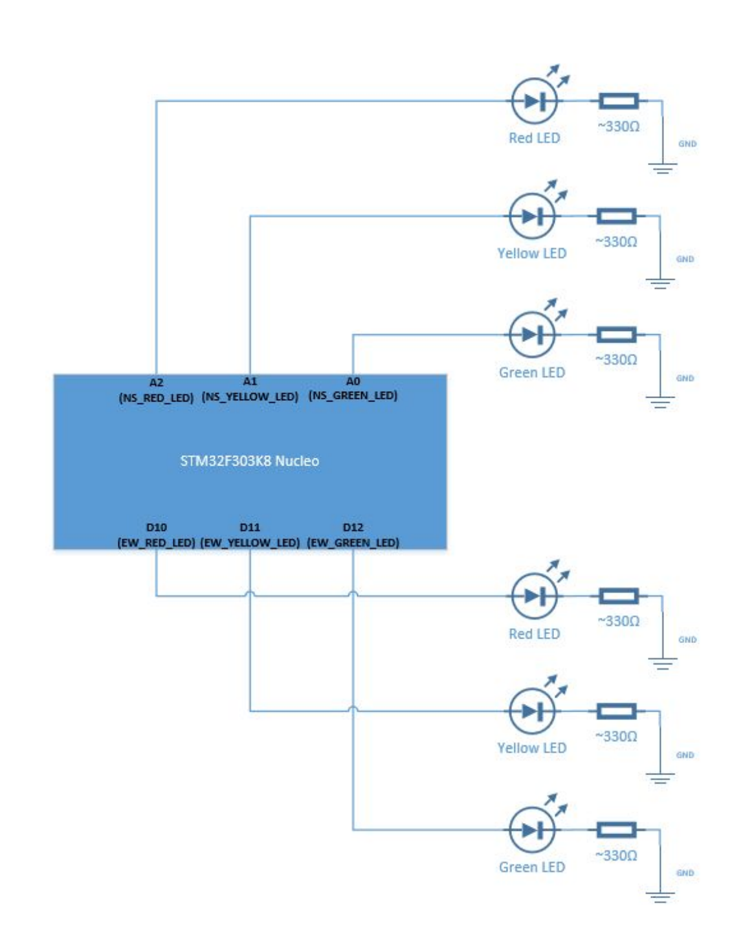  
Live Picture of the circuit.   
  
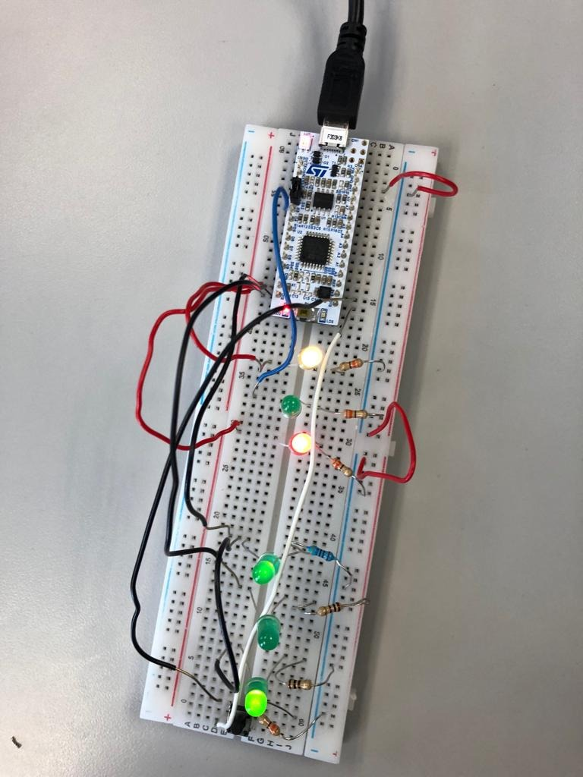

**Part 3: Lab Tools**

|  |  |  |  |
| --- | --- | --- | --- |
| Current State | Input | Next State | Output |
| North-South Pass/ East-West Stop | Timer delay < 10s | North-South Pass/ East-West Stop | NS_Green_led = 1 NS_Yellow_led=0 NS_Red_led=0 EW_Green_led =0 EW_Yellow_led=0 EW_Red_led=1 |
| Timer delay == 10s | Transition North-South |
| Transition North-South | Timer delay < 5s | Transition North-South | NS_Green_led = 0 NS_Yellow_led=1 NS_Red_led=0 EW_Green_led =0 EW_Yellow_led=0 EW_Red_led=1 |
| Timer delay == 5s | All Stop EW |
| All Stop EW | Timer delay < 5s | All Stop EW | NS_Green_led = 0 NS_Yellow_led=0 NS_Red_led=1 EW_Green_led =0 EW_Yellow_led=0 EW_Red_led=1 |
| Timer delay == 5s | North-South Stop/ East-West Pass |
| North-South Stop/ East-West Pass | If button hasn’t been pressed | North-South Stop/ East-West Pass | NS_Green_led = 0 NS_Yellow_led=0 NS_Red_led=1 EW_Green_led =1 EW_Yellow_led=0 EW_Red_led=0 |
| Button has been pressed | Transition East-West |
| Transition East-West | Timer delay < 5s | Transition East-West | NS_Green_led = 0 NS_Yellow_led=0 NS_Red_led=1 EW_Green_led =0 EW_Yellow_led=1 EW_Red_led=0 |
| Timer delay == 5s | All Stop NS |
| All Stop NS | Timer delay < 5s | All Stop NS | NS_Green_led = 0 NS_Yellow_led=0 NS_Red_led=1 EW_Green_led =0 EW_Yellow_led=0 EW_Red_led=1 |
| Timer delay == 5s | North-South Pass/ East-West Stop |

**The State Diagram for the Finite State Machine**

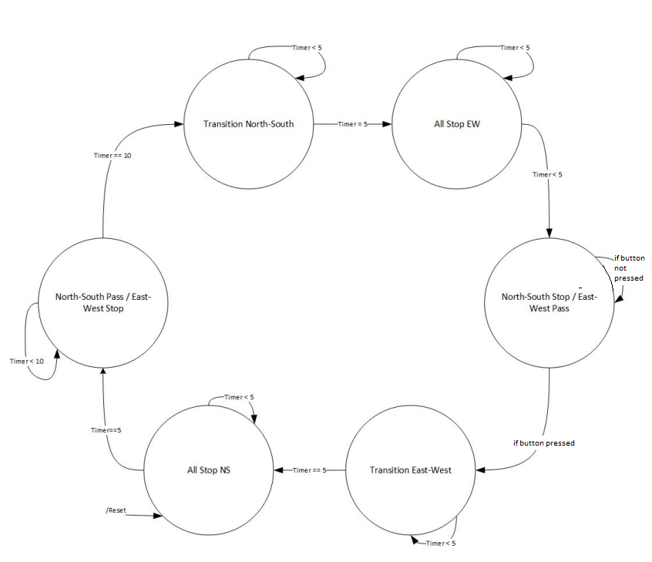

**Part 3: Lab Tools**

In this section, we are going to examine waveforms of out application using Analog Discovery.  
The Analog Discovery can be a extremely useful debugging tool utilized in future labs and projects.

* We connected the Analog Discovery to the circuit  
    
  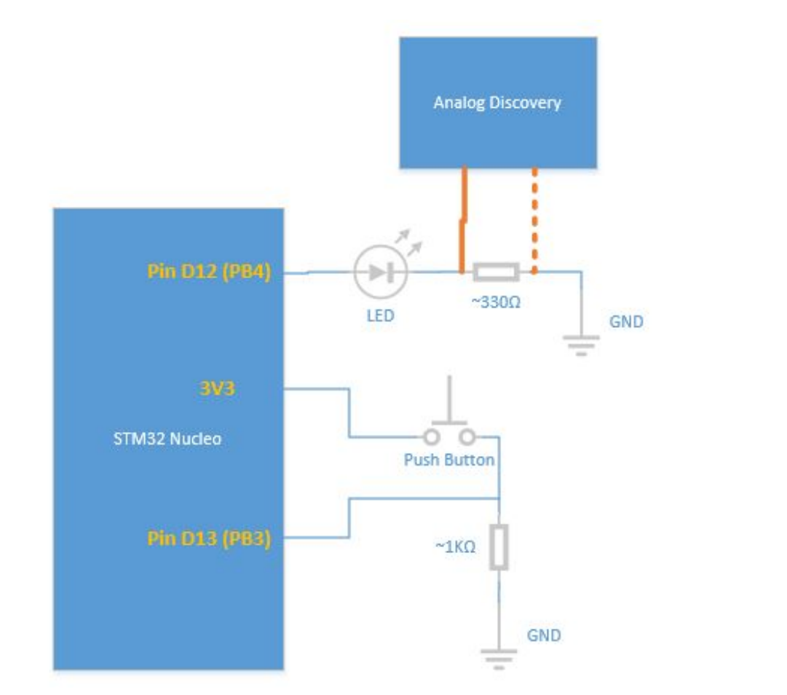  
  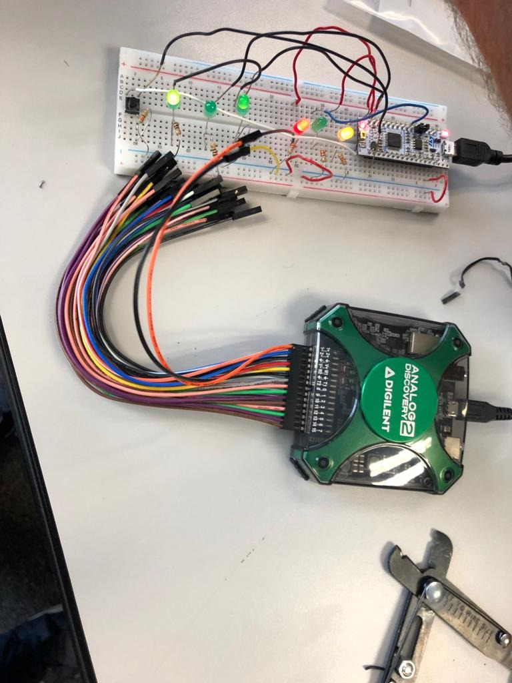
* We started Waveforms and navigate to Logger.   
    
    
  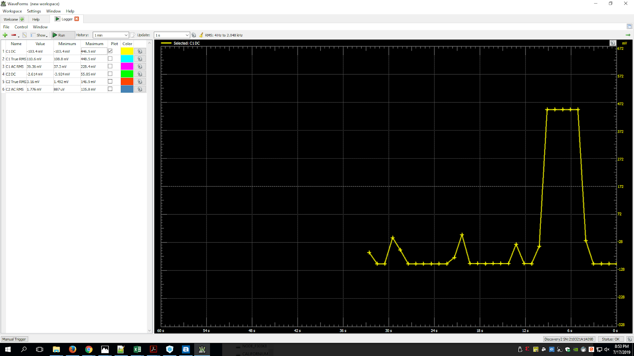
* Logger after LED and before LED

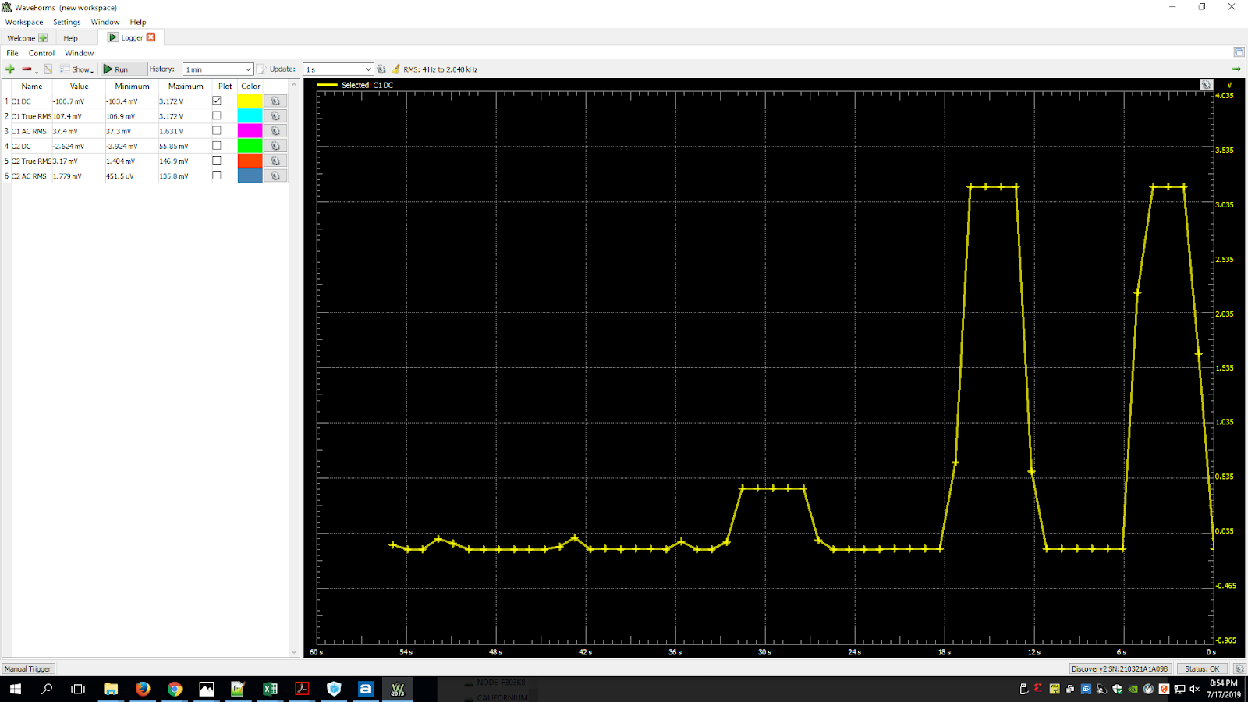

* Oscilloscope. For this part we will need to create a new project toggles the LED at Pin D12, add a delay of 250ms.

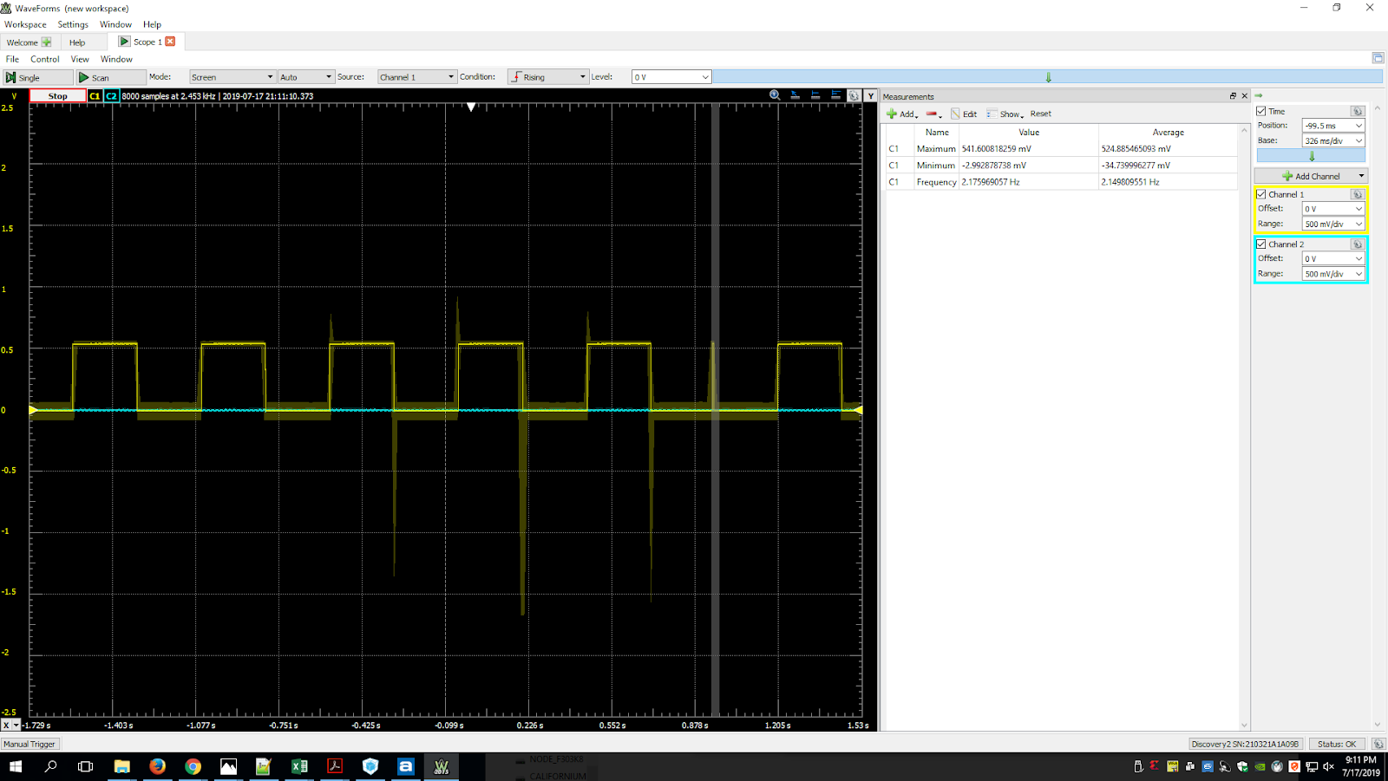

* Logic Analyzer. We back to the home screen for Waveforms, and we place the digital io signal 0, pink lead, to the anode side of the LED  
    
  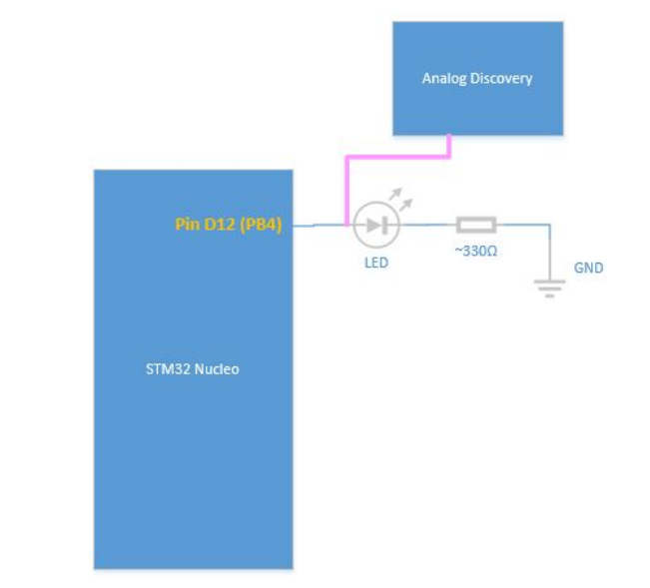
* The Waveform simulation

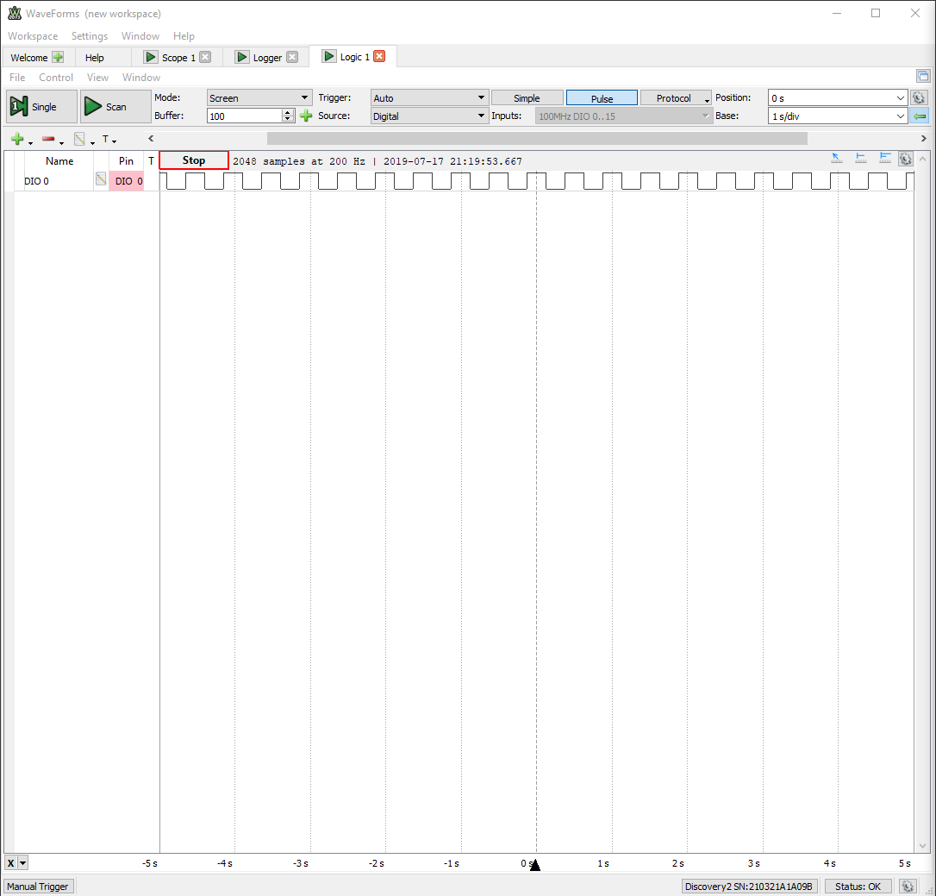

* Arbitrary Wave Generator (AWG). The Wave generator. We connect positive channel 1 (orange lead) to the wave 1(yellow lead), and the negative channel 1 to ground lead on the STM32 board.  
    
    
  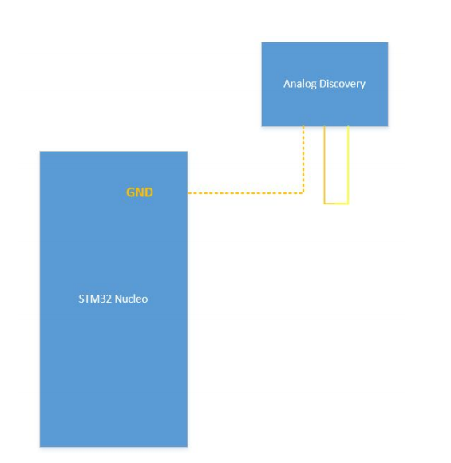

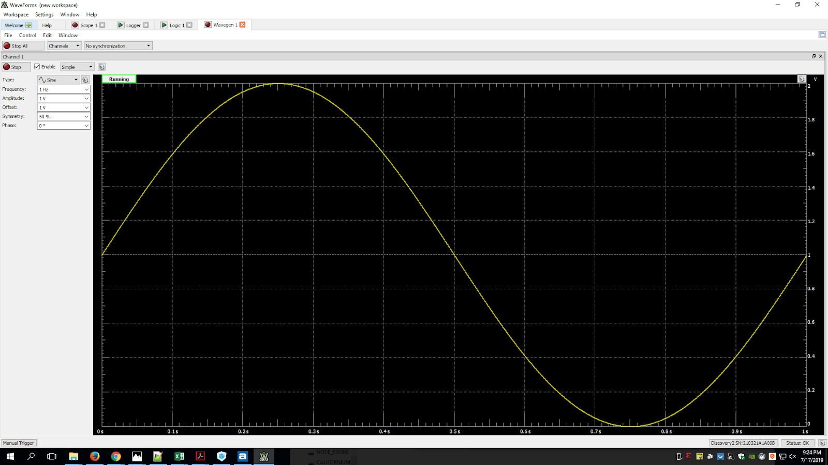

* The Oscilloscope of Generator  
    
    
  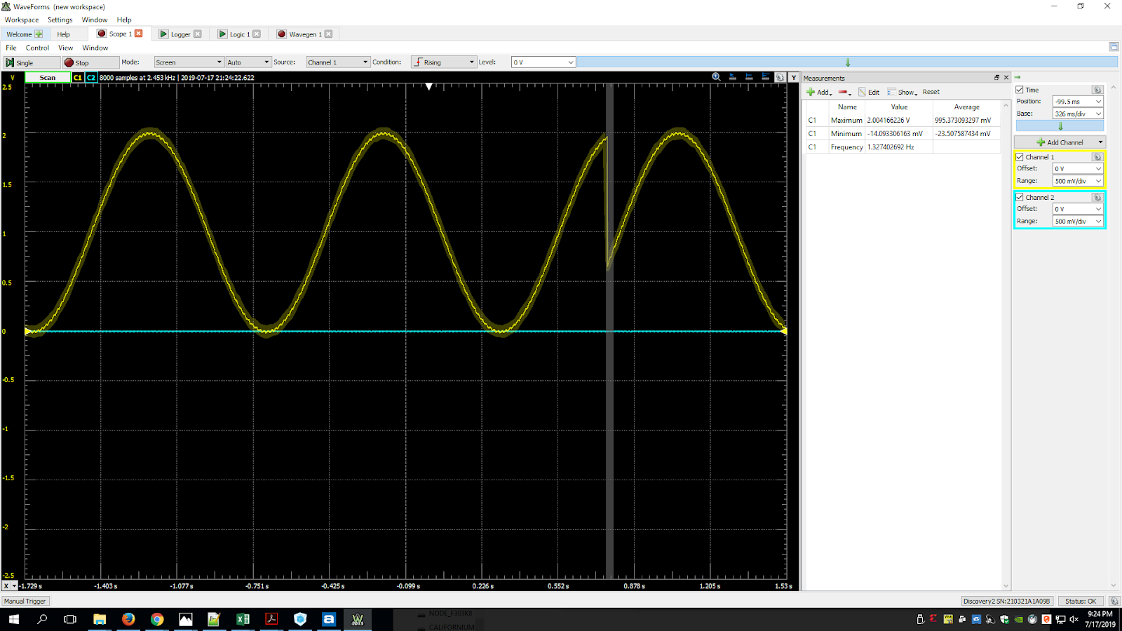
* We confirmed that the AWG is working properly. We navigated through the different wave types and settings. The AWG tool is a great way to simulate signals that our microcontrollers can read using Analog to Digital Converters (ADC).